Name: Pranali Sonawane
Subject: MCSA
Date: 12-12-2025
Lab: Account Policy and Password Policy and Group Policy Folder Direction :

Account Policy:
Server1:
Tools Group Policy Management Microsoft.com Default Domain Policy Right click on edit Computer Config Windows Settings Security Setting Account Policy Account threshold enter 5 invalid logon attempts and Reset account lockout counter after (30 min) Refresh
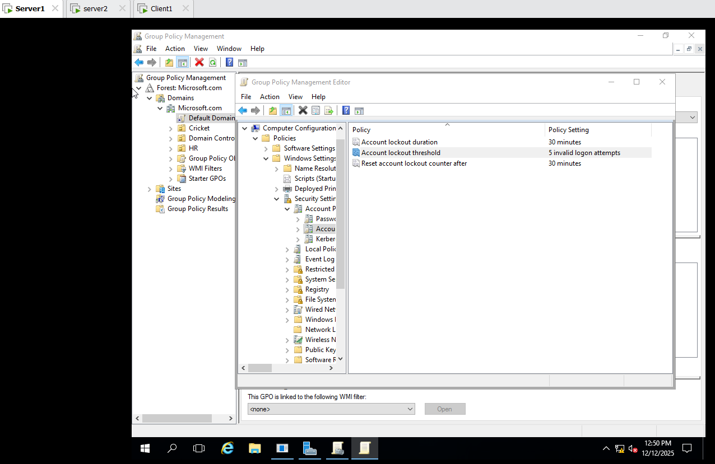

Open the Client1:
login on Hr1 Enter 5 time invalid password

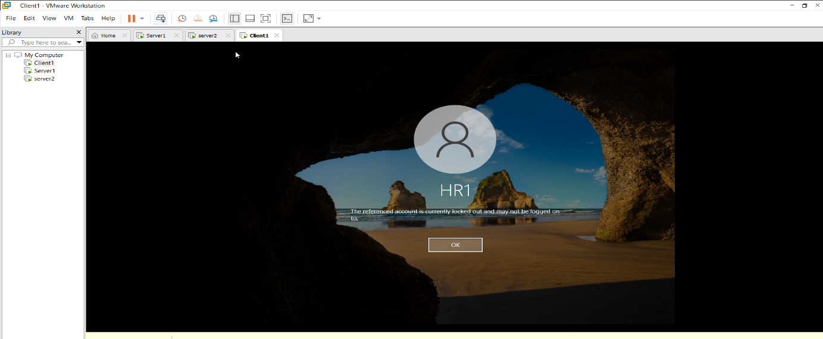
Go to the Server1 Tool Active Directory Users and Computer HR click on HR1 Properties Account click on Unlock Apply.
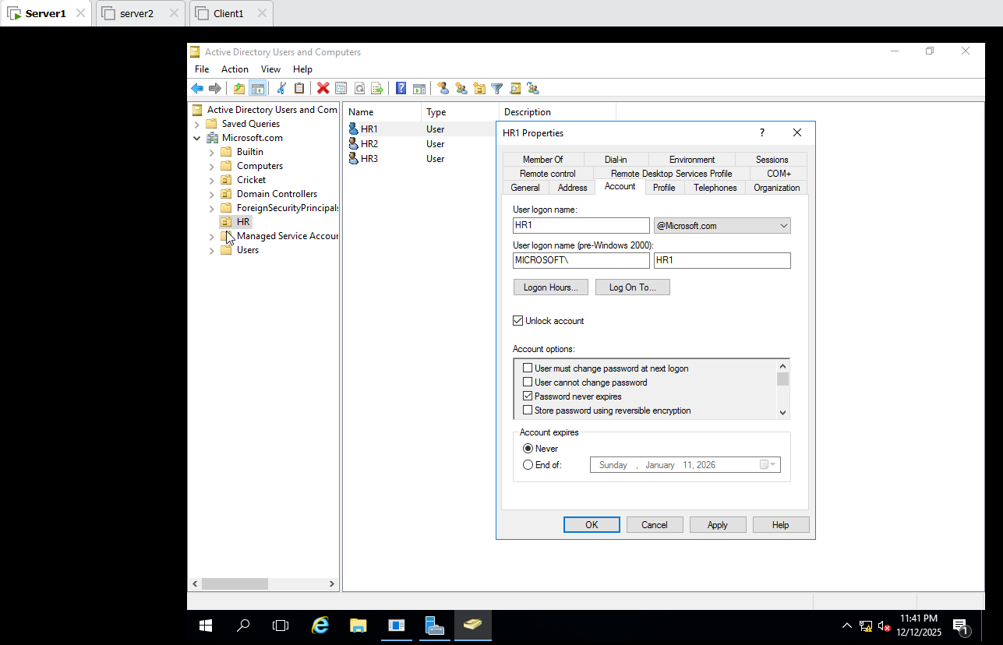

Then Login on Client1 HR1 User

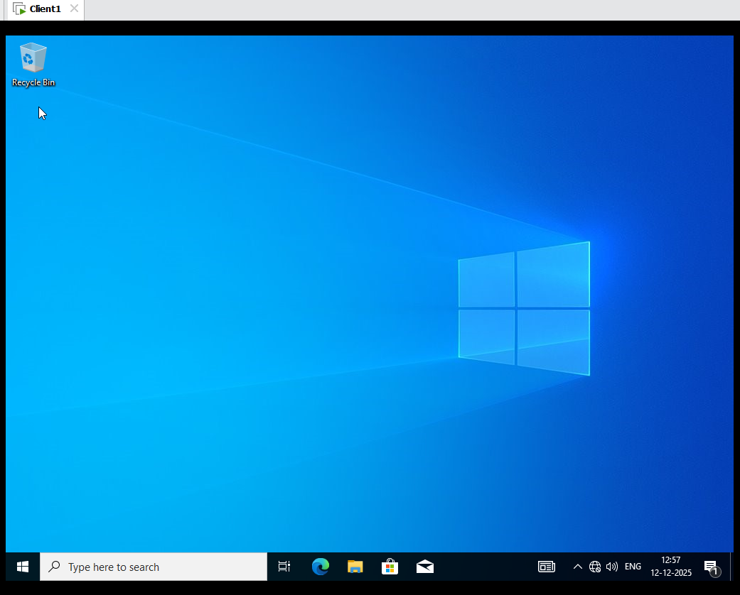
Password Policy:
Server1 : Group Policy Management Microsoft.com Default Domain Policy Right click on edit Computer Config Windows Settings Security Setting Account Policy Password Policy check on minimum password length default 7 character set 14 character.

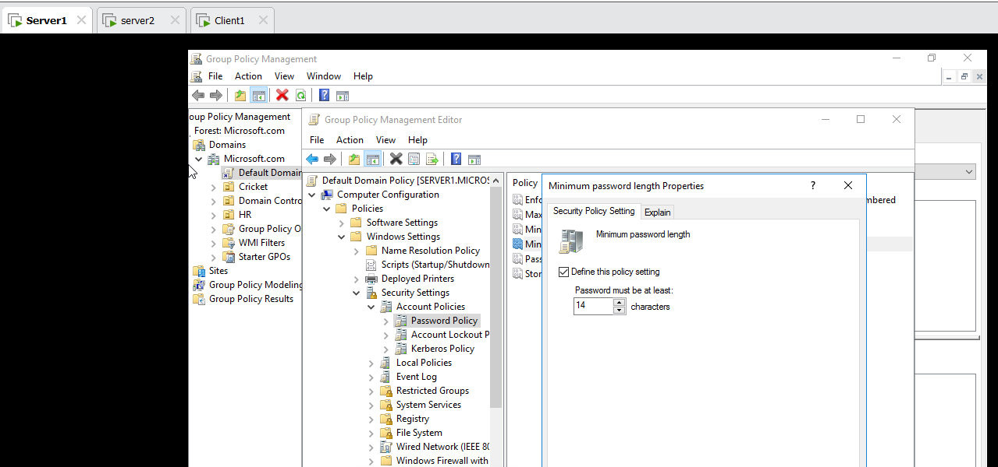
Cmd : gpupdate /force forcefully apply update policy.
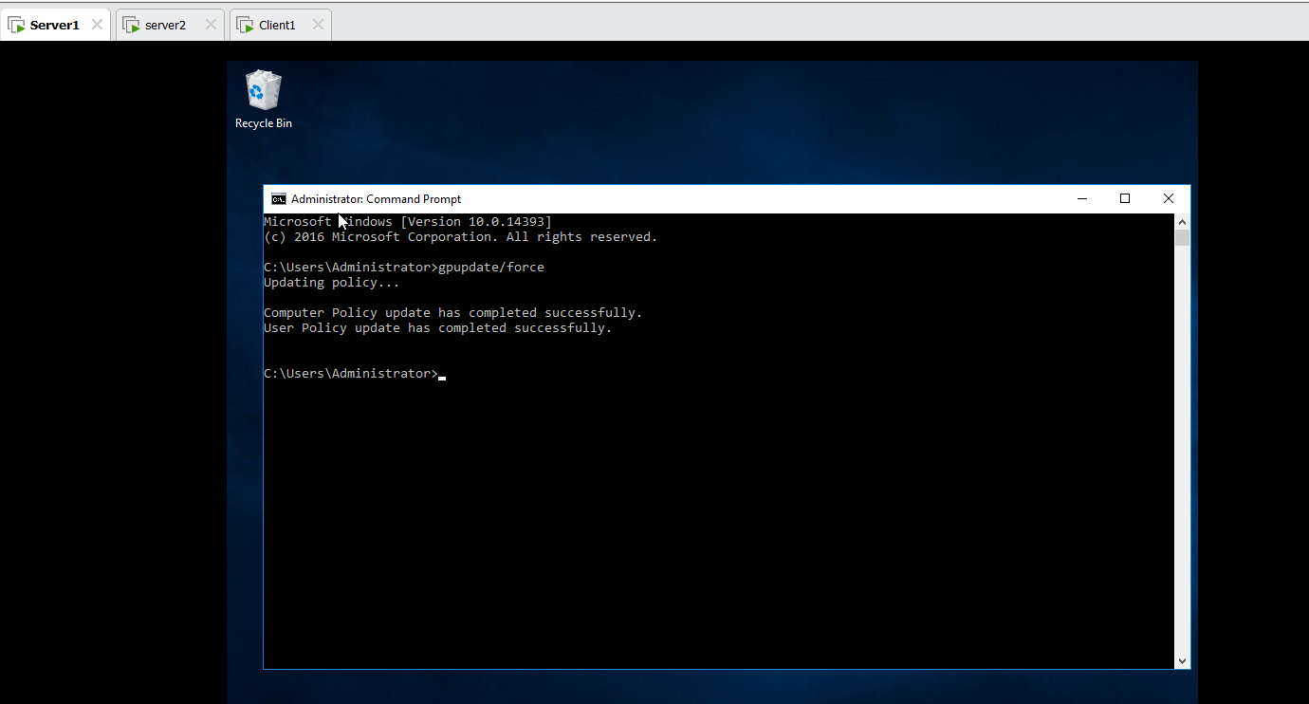
Go to the Server1 Tool Active Directory Users and Computer Microsoft.com new User Priti set: Password@123 finish error message show
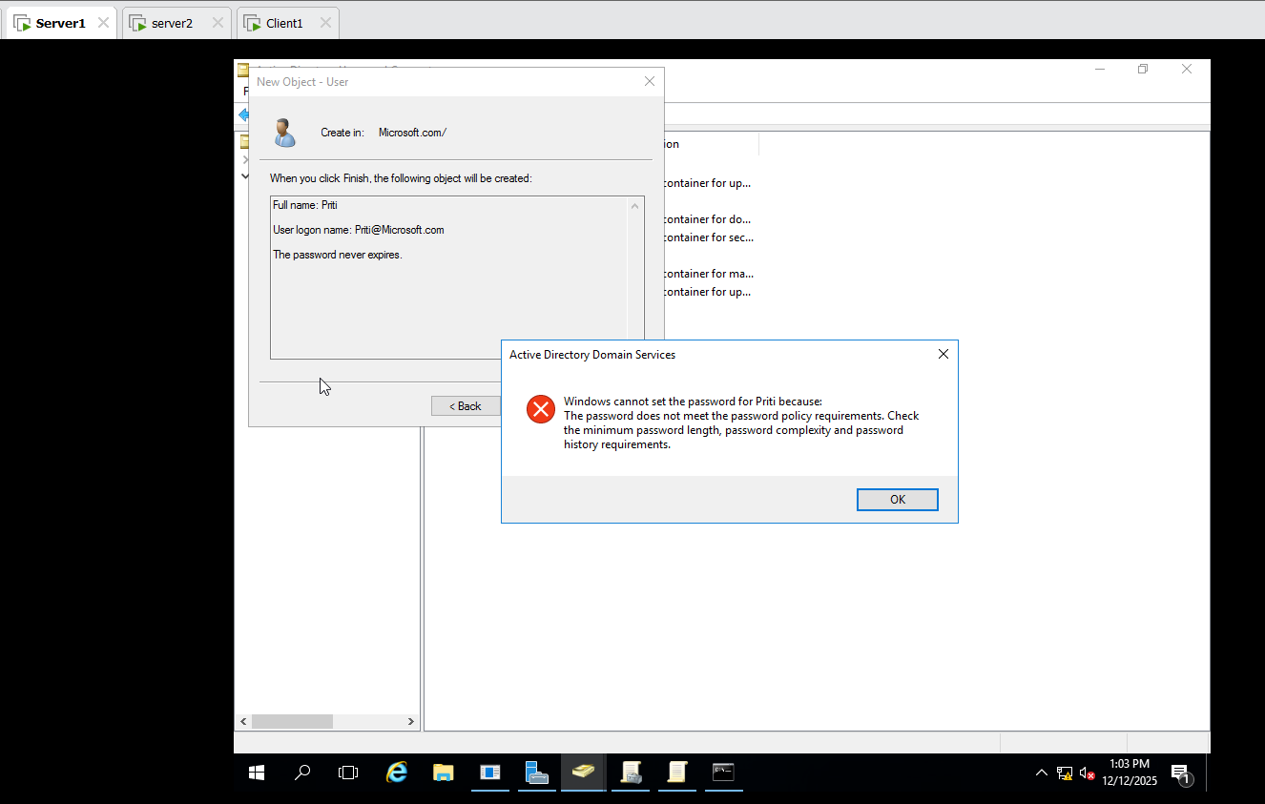
Priti set: Password@12345 finish Priti user.
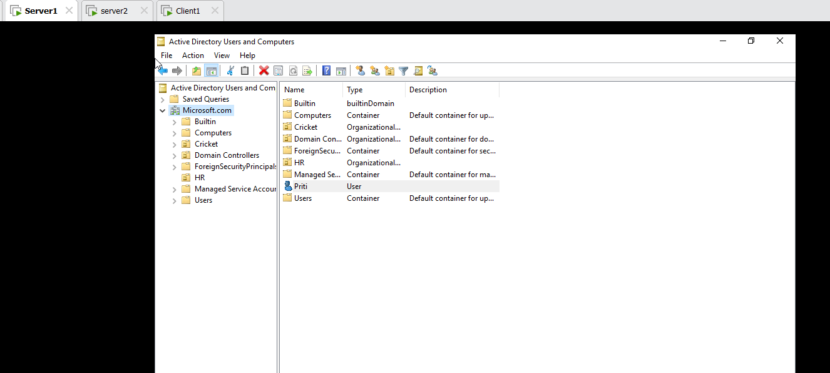
Client1 login on Microsoft\Administrator

Group Policy Folder Direction :
- Create a folder on Server1
- Share the Folder
- Permission full Control for share Permission and NTFS full control
- Setting in group policy
- Check
Server1: Login on Microsoft\Administrator
C drive Create on Documents Folder Properties
click on Sharing Add Users full control ok Security Users Full control
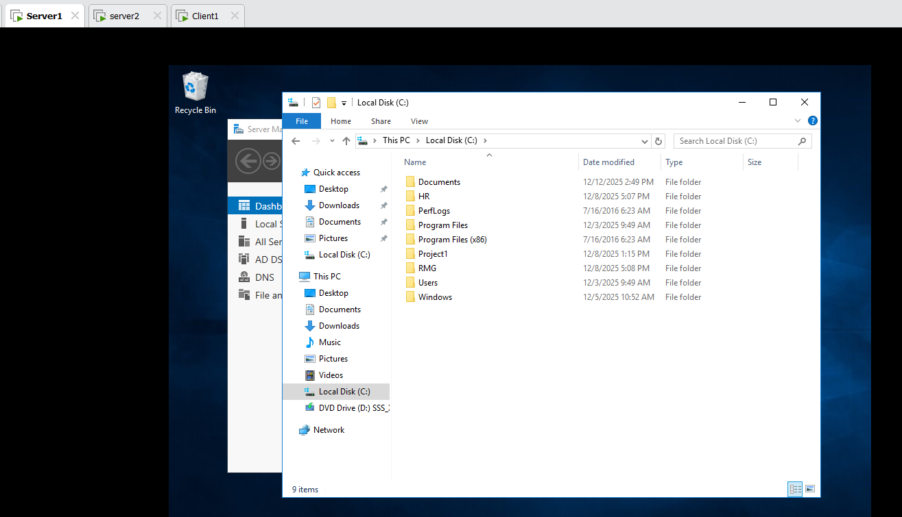
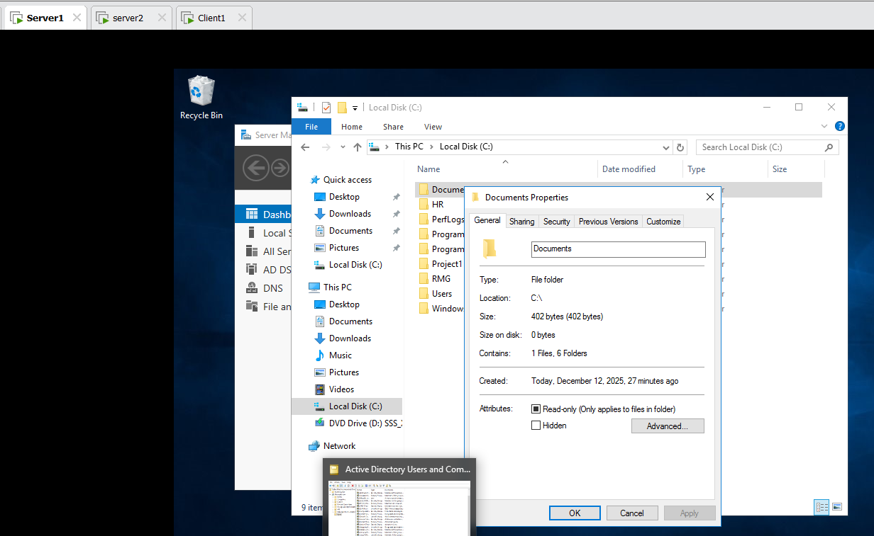
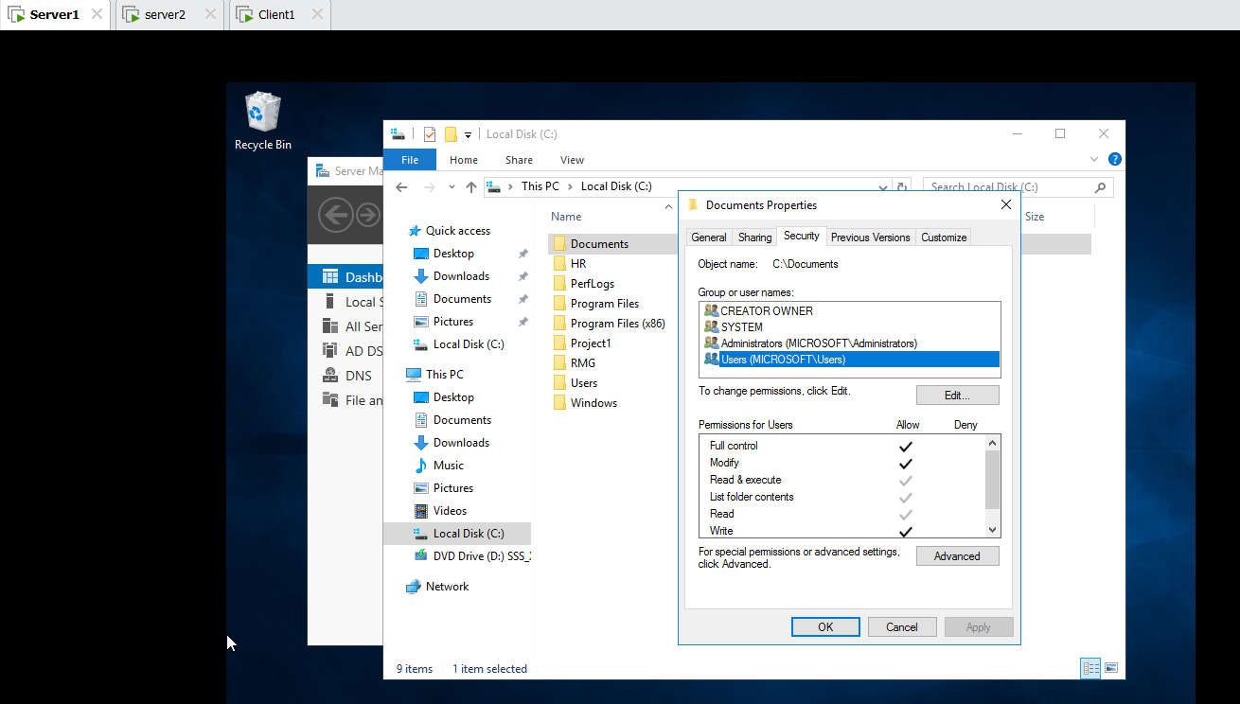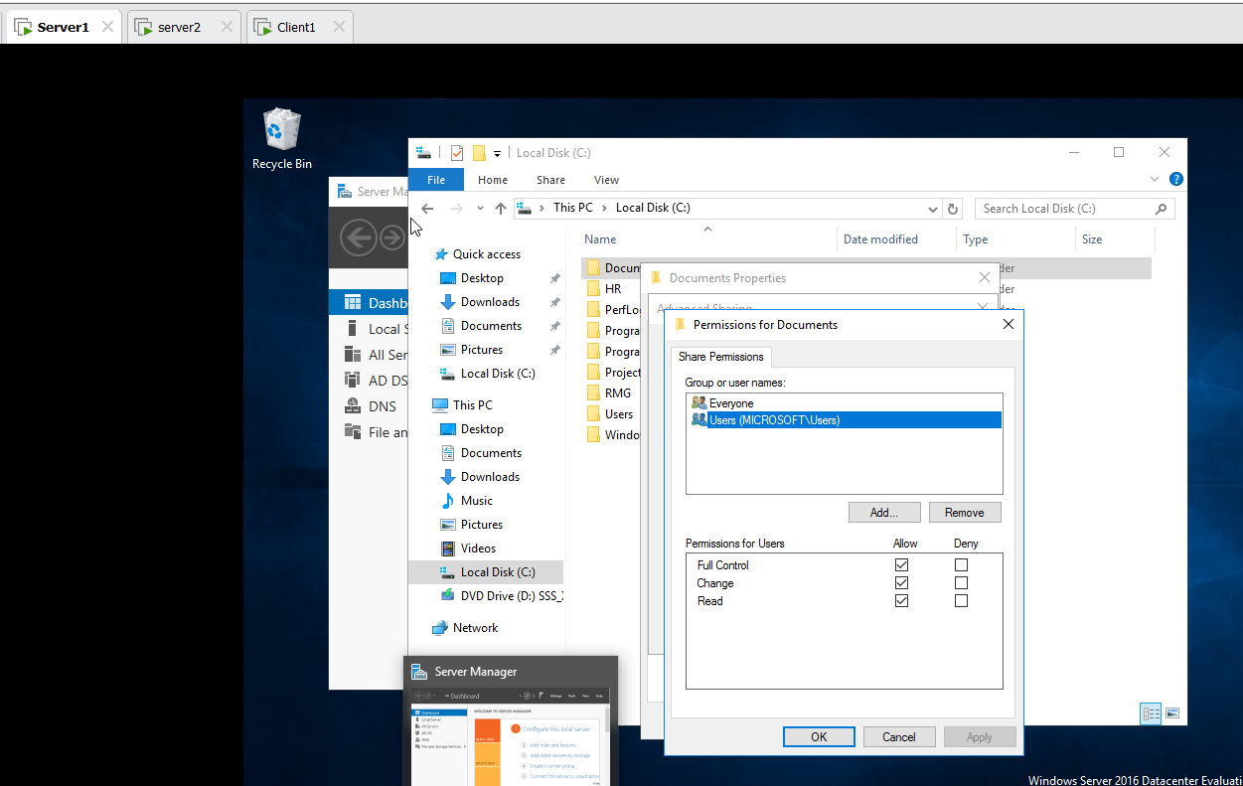
Run \\server1
Tool Group Policy Management Microsoft.com Default Domain Policy Right click on edit User Config Windows Settings Folder Redirection Documents Properties Select on Basic Root Path write \\server1\Documents --> ok
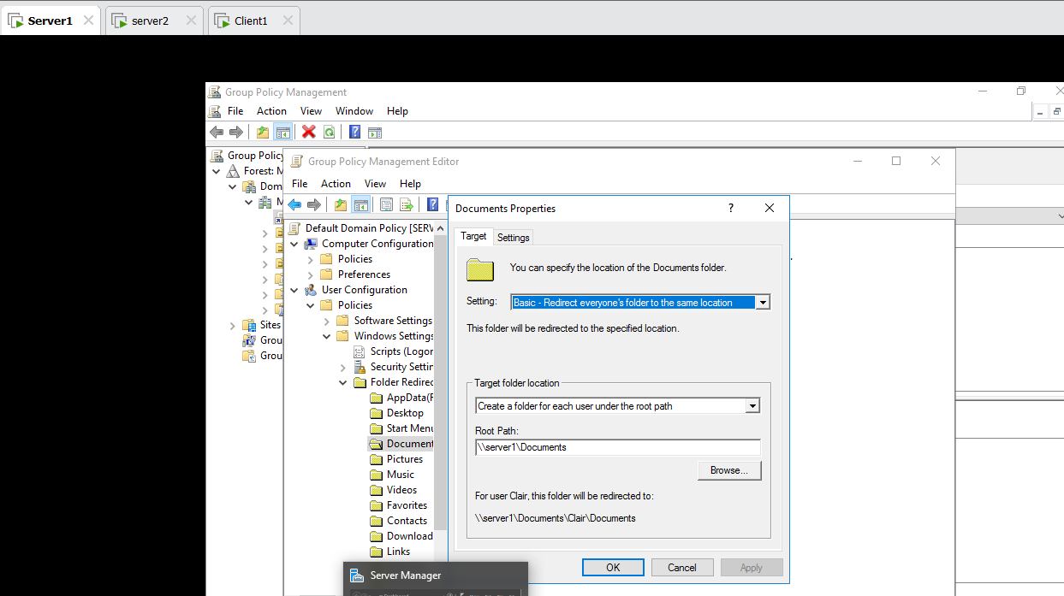
Tools Active Directory Users and Computer Microsoft.com Priti User Move to the Users
Client1 : Login Microsoft\Priti
In C drive Documents Crete a text Document (abc)
Sign out then login Client1 on HR1 Crete a text Document (abc)

Last:
Server1 :- cmd gpupdate/force
Yes
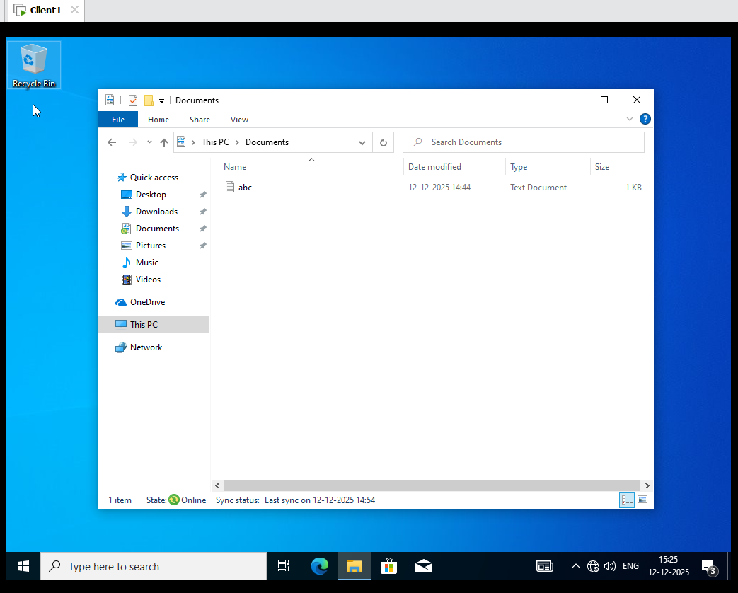
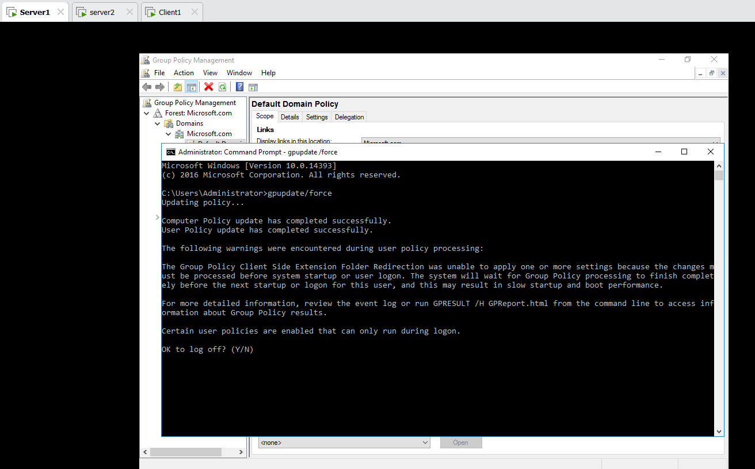
Check on Server1 C drive Documents HR1,Priti and Administrator folder is Present
